# User Guide

**jWebsocket.**

**MapSensors**

**1.0**

Version History ¿

1. **Characteristics of the solution**

MapSensors Allows connected users displaying Their location on a map in real time via the mobile web. It differs from other location-based applications because it works in real time-through the new WebSocket protocol. The application framework on the was developed with jWebSocket, allowing the user to test the potential for real time locating and position distributing in jWebSocket.

jWebSocket allows high number user concurrent connections which ensures a high scalability of the server . Stress tests performed to a server as a result jWebSocket shared 10 000 concurrent connections without affecting the response time of the application. This element not only ensures real-time processes but also a high number of users using the same service at the same time.

**2. Main funcionalities**

**Demo MapSensors functionality:**

**1. Management satellite tracking**

**2. Share real-time location**

**3. Calculation of travel speed**

**4. Display orientation.**

This solution can be used in various areas (which? Please give some examples here) of society, as at present trend is the use of tracking systems, due to ease of use and the use in general. (which use? Please give some!)

**3. Problems to be solved**

|  |  |
| --- | --- |
| **Problem** | **Contributions of the solution** |
| Later in the process of disseminating coordinates on the mobile web  I don’t understand this sentence? The problem is that the location data cannot be shared effectively? | MapSensors allows coordinates spread through the mobile Web in real time through WebSocket protocol.  Please give one sentence what is the benefit of that here. |
| Translation speed calculation is not performed by the accelerometer device.  What is the problem? E.g. accelerometer cannot be used for geolocation without GPS connection? | MapSensors gives the possibility of calculating the speed at which the device is moved by the accelerometer.  Please give one sentence what is the benefit of that here. |

**4. Glossary**

Real-Time on the Web: The real time on the Web is defined as a set of technologies and practices that allow users to receive information as soon as published by their authors, rather than checking a source of regular updates. Replacing request/response mechanisms by permanent connections with less latency and protocol overhead.

Mobile Web: Web access from devices whose main characteristic is the mobility.

WebSocket: is a technology that provides a bidirectional communication channel and full-duplex over a single socket TCP (Transmission Control Protocol), addresses the limitations of the HTTP protocol by establishing a full-duplex communication (TCP) between the client and server, replacing the half-duplex communication (HTTP).

Full-Duplex: A full-duplex allows communication in both directions, and, unlike half-duplex, allows this to happen simultaneously.

Socket: A method for communication between a client program and a server program on a network.

jWebSocket framework: is a new technology aiming to develop WebSockets based applications that provide high levels of speed, scalability, security and real-time work.

Half-Duplex: It means that the method or protocol for transmission of information is bidirectional but not simultaneously, and in http the server can only send data after the client request them.

**5. Model of the solution**

To access the MapSensors the client should use a mobile device (smartphone) with a browser that supports the WebSocket protocol (what about flash and/or the comet fallback? Did you test that?). The client sends requests to the jWebSocket server who is responsible for managing them with the map server. Please explain that a bit more in detail, this is not enough information here. What exactly happens, what is exchanged and why? Purpose?

**7. Requirements for Use**

To use MapSensors your require a mobile device with Internet connection, you must also have the android OS 2.3.3 or higher and have the physical devices accelerometer and GPS. Also the application server must be running. What is “the application server?” The JwebSocket server only, an additional web server like Apache or Tomcat or what? I need more information here!

**8. Roles of the solution**

User: You can log in and see the localization process.

**9. System Operation**

**Main application view**

Give an introductional sentence here what the user can see.

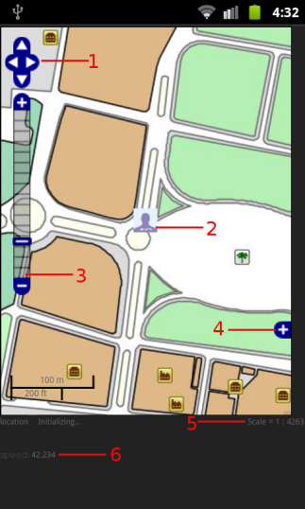

1 --------- Buttons in the display to scroll the map

2 ------- Image representing the location

3--------- Zoom bar

4 ------- Reference map in the lower right corner of the map

5 ------- Scale at which the map is being displayed

6 ------- The speed at which you move the device.

**9. Configurations of the solution**

It does not require specific configurations.

Where does the map data come from? Do you provide some map data for demo purposes? I imaging that your solution will not simply work anywhere in the world or does it? Please explain that to the user.

**10. Rules of the solution**

R1: If the user does not have GPS connection enabled the system issues an error message and does not continue with the normal flow. Solution: The user must activate the device's GPS connection to achieve the full flow of the Location functionality. Could you test that? How? Geolocation?

R2: If the user does not have WIFI enabled the system issues an error message and does not continue with the normal flow. Solution: The user must activate the device's WiFi connection to get the full flow of the Location functionality.

You are talking about Wifi, what about GSM internet connection? I know you can not test that over there, but please tell about possibilities and potential restrictions.